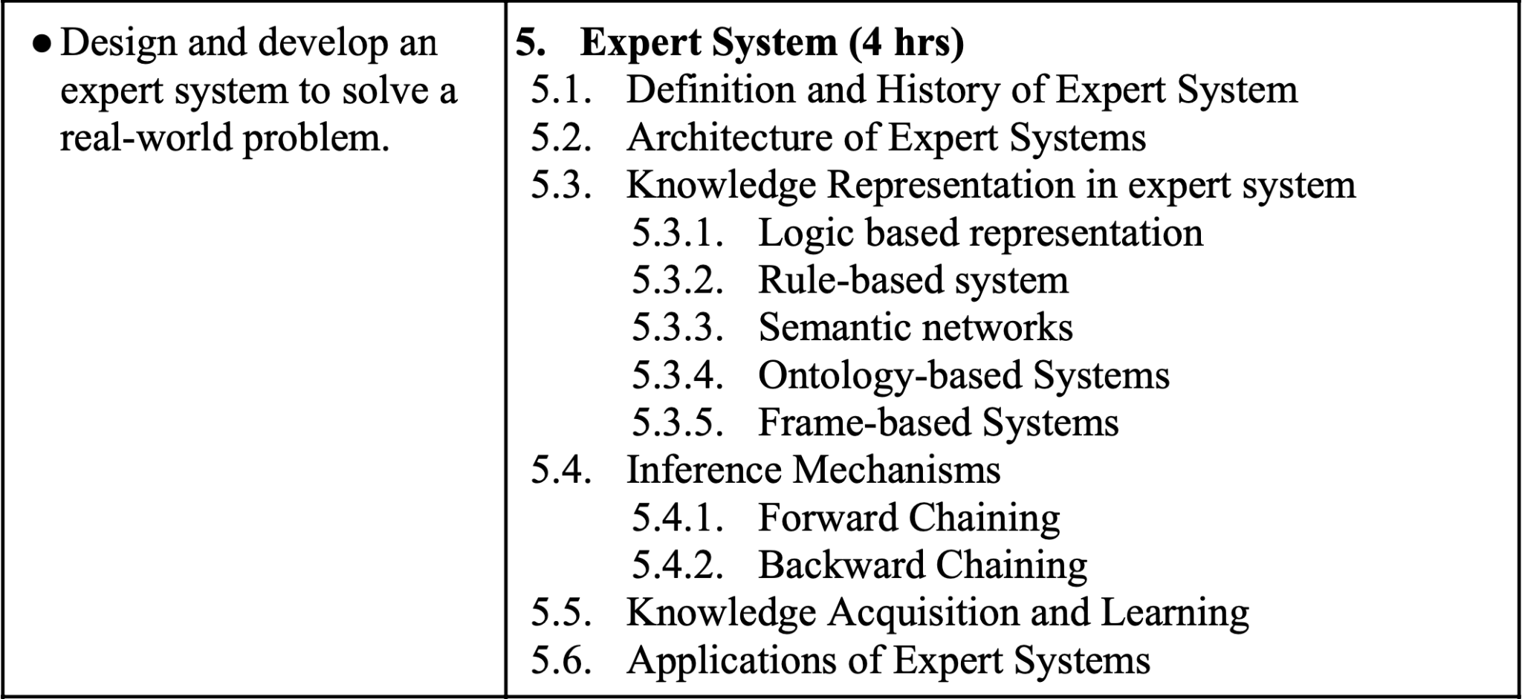

1. Discuss about the significance and architecture of an expert system.
2. Differentiate between semantic networks and frames. Mention examples of each.
3. What do you mean by inference mechanism? Differentiate between forward and backward chaining systems.
4. Construct a semantic net for the following:

*Tom is an instance of a dog. Tom caught a cat. Tom is owned by Roshan. Tom is brown in colour. Dogs like bones. The dog sat on the mat. A dog is a mammal. A cat is an instance animal. All mammals are animals. Mammals have fur.*

1. Represent the following knowledge in Frames:  
   *“****John*** *is a software* ***engineer*** *who works at a technology* ***company****. He has a degree in Computer Science and has been working in the field for five years. He enjoys solving complex* ***problems*** *and loves coding in* ***Python****. In his free time, John likes to play video games and read tech blogs to stay updated on the latest trends in software development.”*